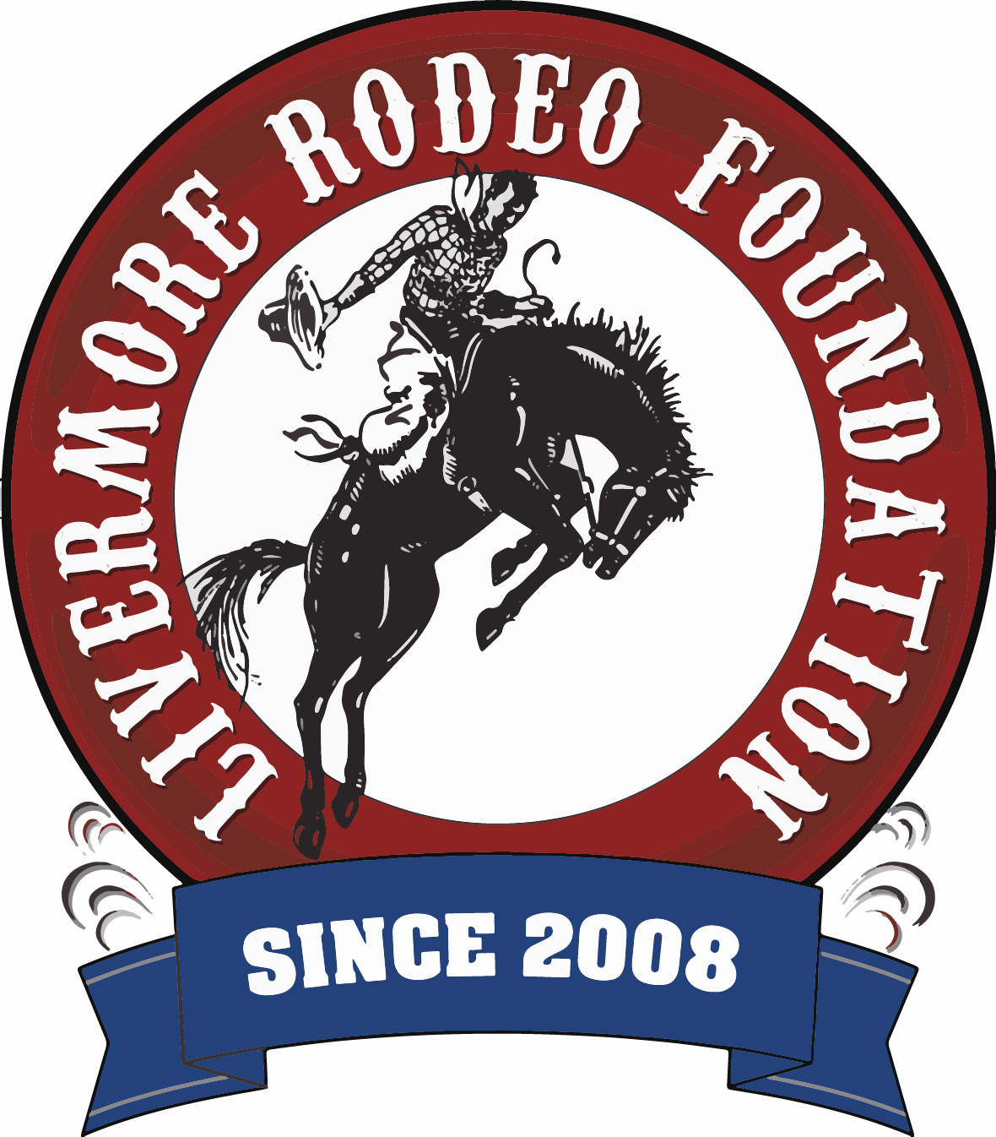

Livermore Rodeo Foundation

PO Box 646

Livermore CA 94551

www.livermorerodeo.com

501c3 Non-Profit Organization

2025 Miss Livermore Rodeo Princess Competition

Application Form

Please write neatly using blue or black ink.

Contestant Name:_______________________­­­_______________________

Address:______________________________________________________

School Contestant Attends:______________________________________________________

Age:_______________________ Birth Date:__________________________

Height: ____________Hair Color: ______________Eye Color: ___________

Long Sleeve Western Shirt Size: (Size for June 2025)

Parent’s Name:________________________________________________

Parents Email #:________________________________________________

Parent’s Phone #:_______________________________________________

Contestants Hobbies and Interest:__________________________________________

___

How did you hear about the Livermore Rodeo Princess Program? ______

_____________________________________________________________

Have you volunteered for a community organization? YES / NO

List Organization(s): _____________________________________________

Description of volunteering activities: _______________________________

List any awards or recognition that you have received (i.e., school, church, sports, community service) _____________________________________________________________

Why do you want to be a Miss Livermore Rodeo Princess? Please explain in fifty (50) words or less in your own writing, on a separate piece of paper.

My signature on this application states I have read all of the contestant information and the information provided is given freely and truthfully.

_____________________________________________________________

Contestant Signature Date

_____________________________________________________________

Parent/Guardian Signature Date

Return Application To:

Livermore Rodeo Foundation

Princess Competition

PO Box 646

Livermore, CA 94551

Entries must be postmarked by Tuesday, April 8, 2025 –

NO EXCEPTIONS

Check or Money Order, non-refundable, in the amount of $40.00 payable to

Livermore Rodeo Foundation

**Please double check that your entry envelope includes all of the required items for submission and you have used the correct amount of postage to avoid any delays.**

Must include in your entry envelope:

1. Completed, signed application
2. Princess program & application fee $40 check or money order to LRF
3. Signed Memorandum of Understanding
4. Signed Waiver of Liability Form
5. Copy of Birth Certificate
6. Copy of Proof of Residency – Acceptable items include – Electric, Water, Garbage and Cable Bill
7. Written 50 words or less “Why do you want to be a Miss Livermore Rodeo Princess”
8. THIS MUST BE EMAILED ON OR BEFORE APRIL 8TH - Contestants will need to provide a short (one sentence) description of themselves to be announced as an introduction at the Princess Coronation. Example: Name, age, and anything you want shared about yourself. Please provide this description typed on a separate piece of paper, along with emailing it to livermorerodeoprincess@aol.com

**To ensure all contestants are starting from an equal competition playing field:**

* All completed Entries must be mailed in to address above and postmarked by Tuesday, April 8, 2025 – NO EXCEPTIONS
* Any applications that are dropped off will not be considered for this competition.
* You will be notified via email a confirmation of your entry.

Thank you for your interest in becoming a Miss Livermore Rodeo Princess! We are very excited about our eleventh year for this program and look forward to meeting our contestants.

If you have any questions, please do not hesitate to contact the Princess Committee Chair - livermorerodeoprincess@aol.com

Stay connected for any updates by liking our Rodeo Facebook Page, Instagram Page and by visiting our Rodeo Website: www.livermorerodeo.com