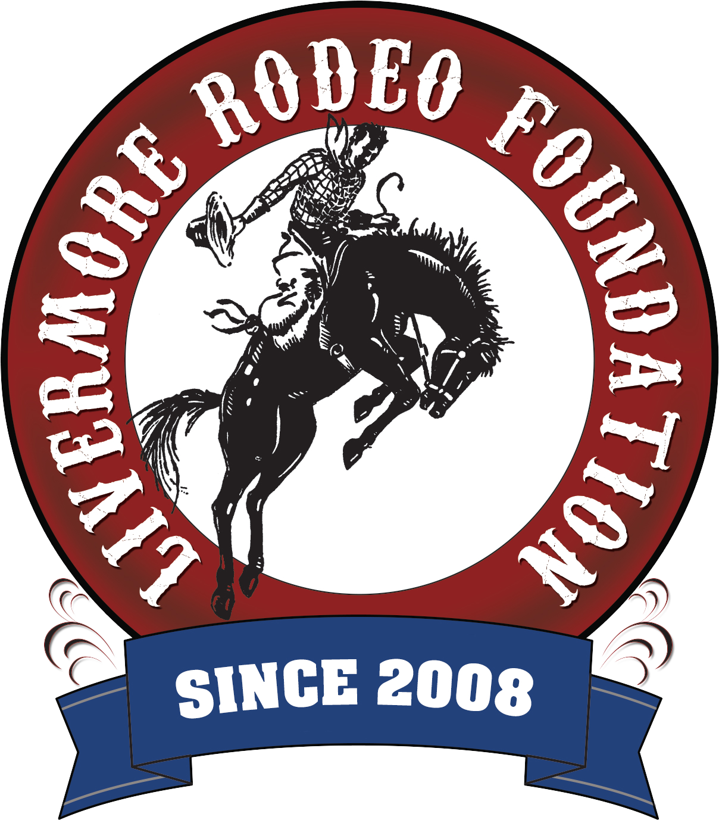

Livermore Rodeo Foundation

PO Box 646

Livermore CA 94551

www.livermorerodeo.org

501c3 Non-Profit Organization

2025 Miss Livermore Rodeo Princess Competition

Welcome!

Thank you for your interest in running for Miss Livermore Rodeo Princess 2025. This will be an exciting experience, which will include community appearances, dinners, rodeos, autograph signings and the opportunity to represent the Livermore Rodeo.

The Livermore Rodeo Foundation in partnership with the Livermore Stockmen’s Rodeo Association is proud to announce we will be crowning up to six (6) local girls, between the ages of 7-12 years old to represent the “Worlds Fastest Rodeo”. This year LSRA celebrates their 107th year and LRF celebrates our 17th year.

Please review the entire packet to make sure you fully understand the competition process and what will be asked of you if you are chosen as one of the Miss Livermore Rodeo Princesses.

Instructions

* Mail completed application, along with the enclosed waiver and MOU
* Entries must be postmarked by Tuesday, April 8, 2025 – NO EXCEPTIONS
* Mail your entry to the Princess Committee:

Livermore Rodeo Foundation

Princess Competition

PO Box 646

Livermore, CA 94551

Include in your entry envelope:

1. Completed, signed application
2. Princess application fee $40 check or money order to: Livermore Rodeo Foundation
3. Signed Memorandum of Understanding
4. Signed Waiver of Liability Form
5. Copy of Birth Certificate
6. Copy of Proof of Residency – Acceptable items include – Electric, Water, Garbage and Cable Bill
7. Written 50 words or less “Why you want to be a Miss Livermore Rodeo Princess”
8. THIS MUST BE EMAILED ON OR BEFORE APRIL 8TH - Contestants will need to provide a short (one sentence) description of themselves to be announced as an introduction at the Princess Coronation. Example: Name, age, and anything you want shared about yourself. Please provide this description typed on a separate piece of paper, along with emailing it to livermorerodeoprincess@aol.com

Should you have any questions please contact Karlie Cromwell and Kim Connors at:

Email: [livermorerodeoprincess@aol.com](mailto:livermorerodeoprincess@aol.com)

Important Information

* The Miss Livermore Rodeo Princess Coronation will be held on Saturday, June 7th, 2025, during a dinner dance event that will take place at the Livermore Rodeo Grounds starting at 6:00 pm.
* There is a MANDATORY CONTESTANT ORIENTATION meeting on Tuesday, April 22, 2025, at 7:00 pm at the Livermore Rodeo Grounds, located at 3000 Robertson Park Road in Livermore (Enter through back gate @Stadium Way). ~ NO EXCEPTIONS! ~
* Contestants are encouraged to seek sponsorships to help share the expenses during her reign as Princess. Some possibilities may include a business, your parent’s employer, friends or relatives employers, etc.
* Contestants are REQUIRED to sell dinner tickets in effort to help sponsor our competition and future princess expenses. You will receive your required tickets to sell at the MANDATORY CONTESTANT ORIENTATION.
* The chosen Princesses will be required to meet with the Princess Committee on Sunday June 8th, 2025, 10:00 am at the Rodeo Grounds for their photo shoot and to discuss and verify their prospective event calendar and the week of Rodeo events.

Qualifications

* Contestants must be 7-12 years of age. Age is determined by your age AS OF January 1, 2025.
* Contestants must reside in Livermore, CA
* Residency is defined as your permanent address where you physically live the majority of the year.

Rules and Regulations

1. Prior to the contest, there is a MANDATORY CONTESTANT ORIENTATION meeting which contestants are required to attend with one (1) parent/guardian to be eligible to enter, which entails an introduction of the Princess Committee members, other contestants, current and/or previous Rodeo Queens, Board Members and Livermore Rodeo Stockholders.
2. This is YOUR contest. You will receive a competition packet at the MANDATORY CONTESTANT ORIENTATION meeting. You will be responsible for ensuring the required items have been completed as outlined in your packet.
3. Although we cannot reveal the items that will be required until the meeting, we can assure you, the tasks are age appropriate, a learning tool for the education of the Rodeo life, introduction of the vital western businesses in our community and in helping preserve the Rodeo tradition for many years to come. You will be allowed to request the assistance of others to complete the tasks. Just remember this is YOUR contest, and you will be required to have the knowledge of how all of the tasks were completed.
4. Contestants must sign, the Memorandum of Understanding, the Waiver of Liability, complete the contest application, and submit the required documents mentioned in the Qualifications section to enter the contest.
5. Contestants must conduct herself in a professional manner, portray high moral standards, and good sportsmanship or she will be disqualified.
6. Contestants will always demonstrate honesty, good behavior & etiquette. This includes but not limited to use of social media such as Facebook, Instagram, Snapchat, TikTok, Twitter/X, Tumbler, Vine and WhatsApp, etc.
7. Contestants are not permitted at any time during the contest, as reigning princess or as a representative of LRF/LSRA, to drink alcoholic beverages, smoke, or use foul language in public.
8. Final decision in all categories will be that of the judges and/or committee members.
9. Pictures taken of contestants by LRF/LSRA photographers during the contest become the property the contracted photographer and may be used for publicity. Copies will be made available to contestants from the contracted professional photographer.
10. Pictures and/or videos may be taken by parents, friends, or relatives of the contestants during the competition, however no outside professional photographers will be permitted to take photos during The Miss Livermore Rodeo Princess Coronation, Fundraiser Dinner & Dance.
11. Contestants are required to provide their own wardrobes. From previous experience, we have found that the crown works best on a felt or thick/sturdy straw hat. It was also noted that for coordinating wardrobes with your fellow contestants, it is recommended that the hat be natural or black in color.
12. Upon arrival to the competition, contestants will be under the jurisdiction and responsibility of the Princess Committee and any designated Chaperones. The committee has complete charge of contestant’s, and one (1) parent or guardian may accompany the contestant for supervision, but will not be allowed to interject or help during the day of competition activities. Of course positive encouragement and support is always acceptable. We do recognize the age of the contestants, and the nuances’ for this type of competition can be intimidating.
13. There will be a personal interview, conducted the day of crowning.
14. Parents, friends, and relatives are welcome to attend the contest activities, and must agree to abide by all rules and regulations.
15. All of the crowned Princesses will be required to dress western when representing the LRF/LSRA in any capacity with their sash, crown and buckle.
16. The Miss Livermore Rodeo Princess crown(s) are the permanent property of the LRF/LSRA. The contest winner’s may keep it in her possession during their year as reigning princess, and will be responsible for returning it in the same condition that it was received.
17. Any problems which arise should quickly be directed to your Princess Coordinator, member of the Committee or and LRF/LRSA Board member.
18. After the coronation, each contestant is expected to stay at the event and behave appropriately as well as show good sportsmanship. Misconduct could cause ineligibility for future contests. The Princess Committee will decide this and all decisions are final.
19. The reigning Princesses cannot hold any additional Princess title while representing the Livermore Rodeo Association.

Contest Divisions

**Written Paragraph**

The instructions and topic will be given the night of the MANDATORY CONTESTANT ORIENTATION meeting and will weigh into your final overall score. This paragraph will be submitted prior to the crowning competition and will be completely in the contestant’s handwriting.

**Dinner Ticket Sales**

Contestants are REQUIRED to sell a minimum number of tickets to The Miss Livermore Rodeo Princess Coronation, Fundraiser Dinner & Dance and it will weigh into your final score. You will receive your tickets at the MANDATORY CONTESTANT ORIENTATION.

**Personal Interview – Age-appropriate questions will be asked**

Interview will take place on the morning of June 7, 2025, which is The Miss Livermore Rodeo Princess Coronation, Fundraiser Dinner & Dance.

The purpose of this judging is to select the contestants who score highest in:

* Knowledge of the competition tasks that were asked of them
* Knowledge and awareness of what they have learned during this contest
* Conversational Ability
* Projection
* Posture
* Eye Contact
* Individuality

Because you will be required to make public appearances as an ambassador, representative and liaison for the Livermore Rodeo Foundation and Livermore Stockmen’s Rodeo Association, you will be judged upon your abilities to conduct your self in-group settings. Among other criteria, you will be judged on:

* Voice
* Enthusiasm
* Delivery
* Effectiveness
* Value and validity of the information you present

**Appearance, Hair and Make-up Guidelines:**

Each contestant is required to dress in age appropriate attire at all times. The goal is for the contestant’s to look as natural as possible. Make-up is allowed but must be kept to a minimum in application. Bling and glitz is allowed.

The following items will not be allowed during the competition.

* Fake Eyelashes
* Extreme Hairpieces
* Flippers
* Spray Tans
* Airbrush Make-up
* Artificial Nails

Livermore Rodeo Foundation

PO Box 646

Livermore CA 94551

www.livermorerodeofoundation.org

501c3 Non-Profit Organization



2025 Miss Livermore Rodeo Princess Competition

Memorandum of Understanding Form

Please write neatly using ink.

This statement represents an agreement, a Memorandum of Understanding (MOU), between the Livermore Rodeo Foundation/Livermore Stockmen’s Rodeo Association, hereinafter referred to as “LRF/LSRA,” and ___________________________________ , a 2025 Miss Livermore Rodeo Princess contestant. The purpose of this MOU is to confirm the contestant’s understanding of the expectations set forth by LRF/LSRA regarding the competition for Miss Livermore Rodeo Princess. It discloses the expectations of Miss Livermore Rodeo Princess and contestants vying for the title.

I understand that by competing in the “Miss Livermore Rodeo Princess” Contest, or by winning the title of Miss Livermore Rodeo Princess, I will be representing LRF/LSRA and the city of Livermore. Furthermore, I will be responsible for promoting the sport of rodeo in its true light to the general public. I further understand that should I not be chosen as one of the 2025 Miss Livermore Rodeo Princesses; I may be asked to represent the Livermore Rodeo Foundation and Livermore Stockmen’s Rodeo Association in the event that the chosen princess is unable to appear at any of the various events. I agree that I will eagerly and enthusiastically participate in activities when invited.

At all times I will strive to portray unexcelled sportsmanship, high morals, ethical character, and humane treatment to animals.

As LRF/LSRA’s representative, I will act, speak, and dress according to the esteem my title deserves any time that I am in the public eye.

If I am chosen Miss Livermore Rodeo Princess, I agree to the following Articles:

ARTICLE

1. I will appear at events to promote the Livermore Rodeo and the City of Livermore throughout my entire reign, and meet the proposed agenda set forth by LRF/LSRA and this MOU. I have reviewed the proposed agenda (sample provided at the end of this document) and completely understand the responsibilities of Miss Livermore Rodeo Princess. In addition, I understand that the proposed agenda is subject to change and some engagements are requested on short notice; nevertheless, I agree to make accommodations to the best of my ability.
2. I will be chaperoned at my events by either parent/guardian(s), LRF/LSRA adult member (adult is 21 years age or older) or approved chaperone, i.e. Miss Livermore Rodeo Pro Queen.
3. I will wear my sash, crown, buckle, and proper western attire whenever I make an appearance as Miss Livermore Rodeo Princess, or for portrait photos for the use of promoting the Livermore Rodeo.
4. I will always demonstrate honesty, good behavior & etiquette. This includes but not limited to use of Social Media such as Facebook, Twitter, Instagram, Snapchat, Vine, Tumbler, etc.
5. I understand that all of my appearances must have LRF/LSRA’s approval. While making any approved appearance, I understand that LRF/LSRA may provide a chaperone(s) to accompany me as feasible, and I will abide by the supervision of chaperone(s).
6. I will comply with this MOU and keep close contact with my coordinator. It is my responsibility to notify my coordinator if: any problems arise, or if I am unable to make any appearances as scheduled. Should I be unable to make any event, I will notify her seven (7) days in advance.
7. I will encourage others to participate in future contests, act as a hostess to contestants in future contests, and assist in the promotion of the contest in any way possible.
8. I understand that I would have to forfeit my title (crown, sash, buckle), if I act in a manner that does not adhere to this MOU. If there are negative reports on my conduct, my coordinator will discuss the matter with me. If there is no resolution to the problem, LRF/LSRA can request that I relinquish my title along with princess items.
9. Finally, I completely understand that the Miss Livermore Rodeo Princess Competition is a contest that recognizes a number of attributes: appearance, personality and public speaking. During the contest, I will exhibit the utmost sportsmanship and conduct myself in a professional manner.

________________________________________________________________________

Contestant Signature Date

________________________________________________________________________

Parent/Guardian of Contestant Date

Livermore Rodeo Foundation

PO Box 646

Livermore CA 94551

www.livermorerodeofoundation.org

501c3 Non-Profit Organization



2025 Miss Livermore Rodeo Princess Competition

Waiver of Liability

In consideration of my application of being accepted for participation in the Miss Livermore Rodeo Princess Competition, I hereby agree to abide by the rules and understand that any violation of the rules and regulations may disqualify me from participation. I further agree to hold harmless the Livermore Rodeo Foundation and Livermore Stockmen’s Rodeo Association and the Miss Livermore Rodeo Princess Contest Committee, their officers, agents, and employees for any claims resulting from the loss, accident or injury received by me in connection with participation by me in any event and performance of this contest.

In conclusion, I hereby release the right, title, and claim of any photographs that may be taken by the management for their use in promotion and publicity. I certify that I have read the rules and regulation of the Miss Livermore Rodeo Princess Competition.

________________________________________________________________________

Contestant Signature Date

________________________________________________________________________

Parent/Guardian Signature Date

________________________________________________________________________

Contestant’s Street Address City Zip Code

________________________________________________________________________

Contestant’s Home Phone Cell Phone if Applicable

**Emergency Contact:**

________________________________________________________________________

Parent/Guardian Name Parent/Guardian Cell Phone

2nd Emergency Contact Name Relationship Cell Phone

Livermore Rodeo Foundation

PO Box 646

Livermore CA 94551

www.livermorerodeofoundation.org

501c3 Non-Profit Organization



2025 Miss Livermore Rodeo Princess Appearances

Below is an expectation of the events and engagements you will be attending. Your Princess Coordinator will notify you of specific dates when they are announced and/or become final. It is your responsibility to maintain your calendar and keep abreast of your scheduled appearances. If you are unsure of any dates, and the Princess Coordinator has not contacted you, PLEASE contract a member of the board to get the necessary dates and times of the events. ALWAYS confirm the dates with the Princess Coordinator!

Please be aware that MANY of the events occur during the week, especially those that occur prior to the rodeo. Those marked with an asterisk (*) are mandatory. Failure to attend more than three appearances will result in possible removal of princess title; final decision is that of the board’s.

There may be other opportunities for appearances and representation, and this list is subject to change by mutual agreement. The events that are listed with an aesthetic (*) are mandatory. Our goal is to give the girls as many opportunities to be out in the community that are realistic and for them to have fun representing the Livermore Rodeo. The items on this list mirror some of the required events for the Miss Livermore Rodeo Pro Queen and will be discussed and finalized at the June 4th meeting.

Rodeo Week 2025

We realize that this is during the last couple of weeks of school and understand that a school commitment will take precedence; princesses are encouraged to attend as many events as possible.

*June 7th 6:00 pm Miss Livermore Rodeo Princess Coronation Dinner & Dance Event

*June 8th 10:00 am Miss Livermore Rodeo Princess Meeting & Photo Shoot

*June 10th 6:30 pm LSRA Board meeting

*June 11th 5:30 pm Livermore Rodeo Mixer

*June 12th 6:00 pm Local Event (this may change)

June 13th 8:00 am PRCA Pro Slack

*June 14th Livermore Rodeo Parade, Livermore Rodeo

*June 14th & 15th Livermore Rodeo

June 21st Livermore Junior Rodeo

**July or August 2025**

July 27, 2025 Little League World Series Lunch

**October – November 2025**

May have appearances to attend with Miss Livermore Pro Queen and Miss Livermore Jr. Rodeo Queen. This will be by mutual decision with your Princess Coordinator.

**December 2025**

*December 6th Livermore Holiday Parade

**January – April 2026**

* Picture with LRF & LSRA Boards for Program

May have appearances to attend with Miss Livermore Pro Queen and Miss Livermore Jr. Rodeo Queen. This will be by mutual decision with your Princess Coordinator.

* Miss Livermore Jr. Rodeo Queen Contest

* Miss Livermore Pro Rodeo Queen Contest & Dinner

**May 2026**

* Livermore Downtown Festival

* Chamber of Commerce Mixer – Alden Lane Nursery

* Rowell Ranch Rodeo & Parade

* Livermore Farmer’s Market

**June 2026**

* 2026 Miss Livermore Rodeo Princess Competition

* LSRA General Board Meeting

* LRF Meeting